**Part 1:**

**1. pwd 2. cd 3. ls 4. Mkdir** **5. rm 7. Hostname 6. touch 8. Cat 10. Echo 11.grep 12.fgrep**

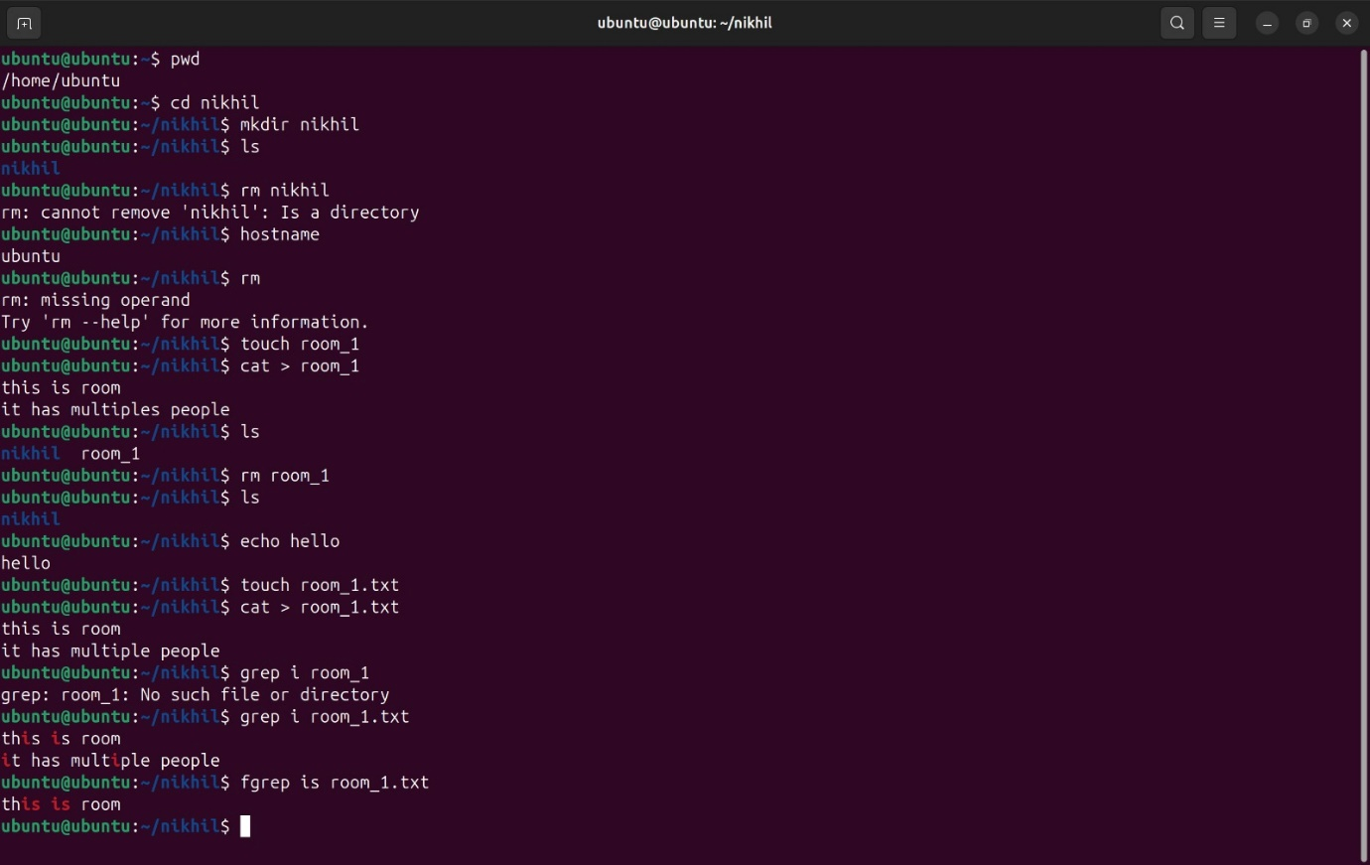

**14. cp 15. more 16. Less 17. wc**

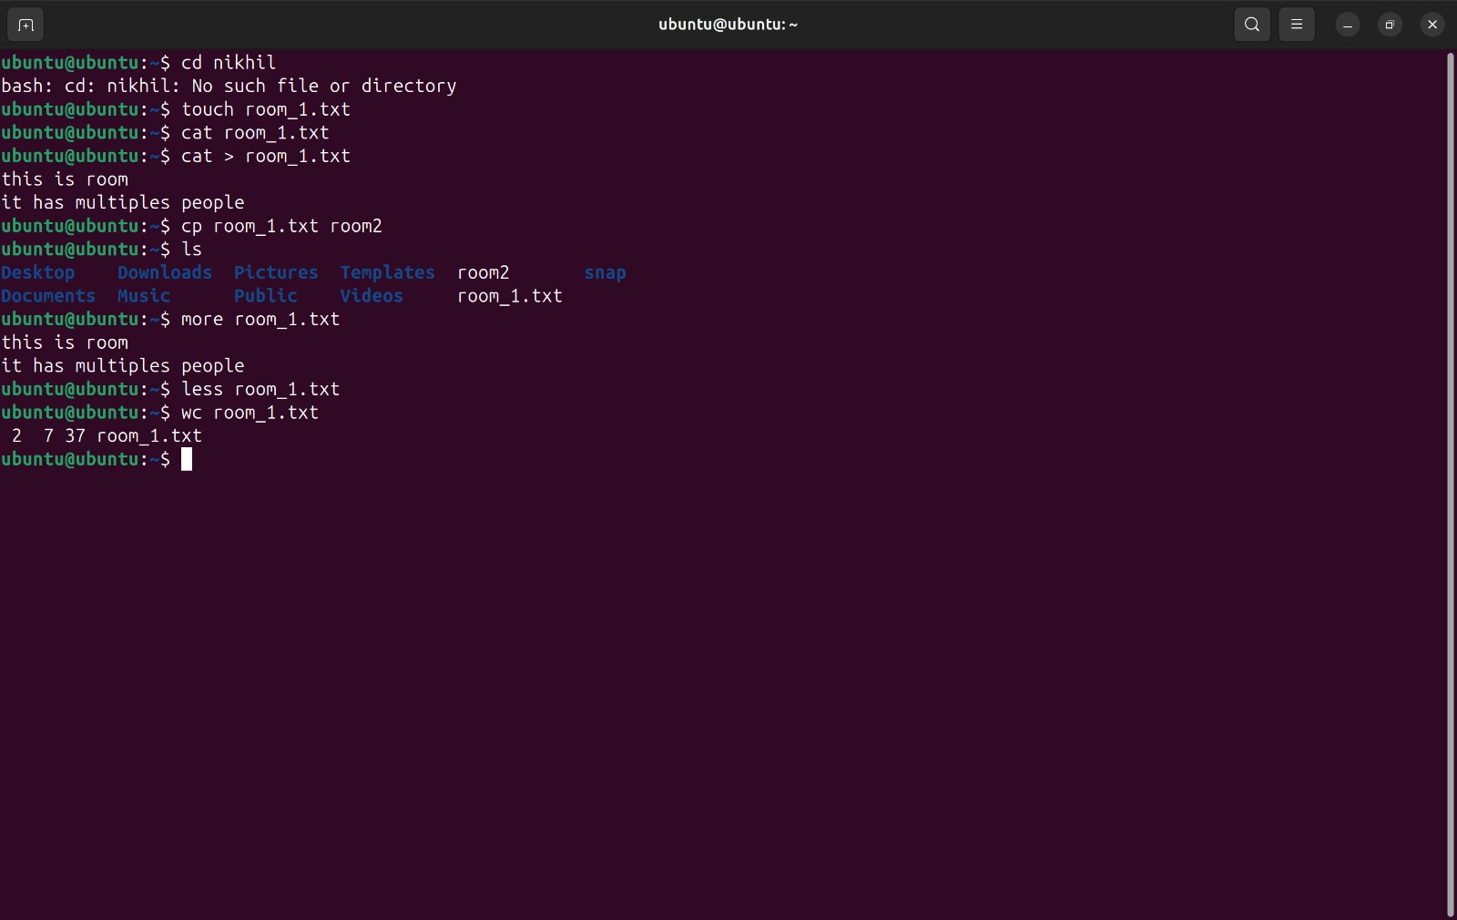

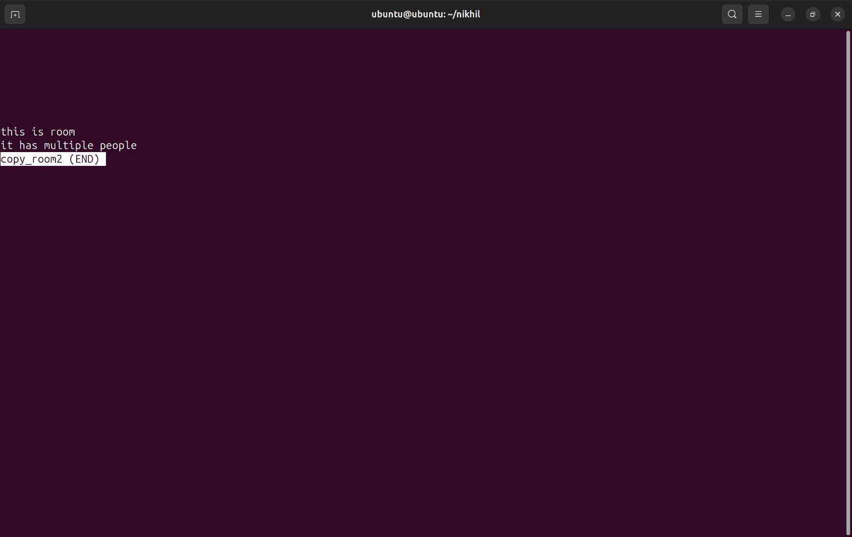

**18. awk 20. Tail 13. Mv 9. chmod**

**19. sed**

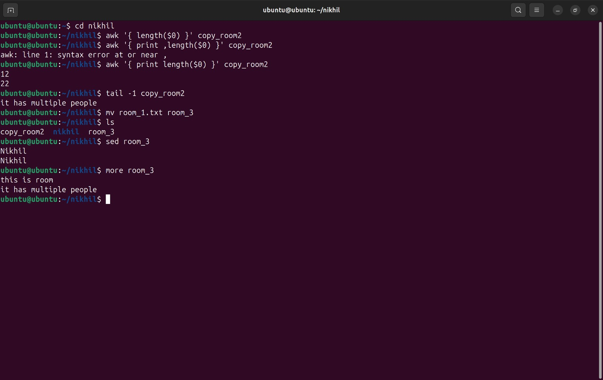

**Part 2:**

1. How to navigate to a specific directory?

**cd /path/to/directory**

1. How to see detailed information about files and directories using ls?

**ls -l**

1. How to create multiple directories using mkdir?

**mkdir dir1 dir2 dir3**

OR create nested directories:

**mkdir -p parent/child/grandchild**

1. How to remove multiple files at once with rm?

**rm file1 file2 file3**

1. Can rm be used to delete directories?

**rm -r directory_name**

1. How do you copy files and directories in Linux?

Copy a file:

**cp file1 destination/**

Copy a directory:

**cp -r dir1 destination/**

1. How to rename a file in Linux using mv command?

**mv old_filename new_filename**

1. How to move multiple files in Linux using mv command?

**mv file1 file2 file3 destination_directory/**

1. How to create multiple empty files using touch command in Linux?

**touch file1 file2 file3**

1. How to view the content of multiple files in Linux?

**cat file1 file2**

1. How to create a file and add content using cat command in Linux?

**cat > filename**

*Then type the content and press Ctrl + D to save.*

1. How to append contents of one file to the end of another file using cat command?

**cat file1 >> file2**

*This appends file1 content to file2.*

1. How to use cat command if the file has a lot of content and can’t fit in terminal?

**cat large_file | more**

OR

**cat large_file | less**

1. How to merge multiple files using cat command?

**cat file1 file2 > merged_file**

1. How to use cat command to append to an existing file?

**cat new_content.txt >> existing_file.txt**

1. What is “chmod 777” or “chmod 755” and “chmod +x” or “chmod a+x”?

**chmod 777 file** → Full permissions for everyone.

**chmod 755 file** → Owner has all permissions, others can read/execute.

**chmod +x script.sh** → Makes a script executable.

**chmod a+x script.sh**→ Makes a script executable for all users.

1. How to find the number of lines that match a string/pattern?

**grep -c "pattern" file.txt**

1. How to display files that contain a given string/pattern?

**grep -l "pattern" *.txt**

1. How to show the line number of file with the line matched?

**grep -n "pattern" file.txt**

1. How to match lines that start with a string using grep?

**grep "^pattern" file.txt**

1. Can sort command be used to sort files in descending order by default?

**sort -r file.txt**

1. How to sort a file based on a specific column using sort command?

**sort -k 2 file.txt**

*Sorts based on the second column.*